Christophe Pourny studio is proud to announce the release of our first book:
The Furniture Bible
-every thing you need to know to identify, restore, and care for furniture
by Christophe Pourny with Jen Renzi
published by Artisan Books –an imprint of Workman Publishing
Photography – James Wade Studio
Foreword by Martha Stewart

Christophe Pourny learned the art of furniture restoration in his father’s atelier in the South of France. In this, his first book, he teaches readers everything they need to know about the provenance and history of furniture, as well as how to restore, update, and care for their furniture—from antiques to midcentury pieces, family heirlooms or funky flea-market finds. The heart of the book is an overview of Pourny’s favorite techniques—ceruse, vernis anglais,and water gilding, among many others—with full-color step-by-step photographs to ensure that readers can easily replicate each refinishing technique at home. Pourny brings these techniques to life with a chapter devoted to real-world refinishing projects, from a veneered table to an ebonized desk, a gilt frame to a painted northern European hutch. Rounding out this comprehensive guide is care and maintenance information, including how to properly clean leather, polish hardware, fix a broken leg, and replace felt pads, as well as recipes to make your own wax, shellac, varnish, stain, and more

Praise for The Furniture Bible

“Encyclopedic in coverage . . . deftly illustrated and defined . . . a fantastic go-to source for furniture care.”
—Library Journal, starred review
“A thorough and practical guide for the furniture expert as well as for the novice restorer. . . . This guide will find a wide audience among those who simply want to learn about and appreciate good furniture, as well as those who are more hands-on.”
—Publishers Weekly, starred review
“This is a very useful and important book for anyone who owns furniture—antique, modern, or new—or anyone who plans to fix or restore it.”
—Martha Stewart

“it’s really everything you wanted to know about furniture, but were afraid to ask”
-Women’s Wear Daily

“A guide for the pros, DIYers and furniture aficionados eager for tips from the expert. Pourny’s practical advice on all things antique is coupled with historical notes.”
—Time

“Authority wafts from [Pourny’s] handsome how-to book like the sweet smell of lemon oil.”
—New York Times

“Pourny’s book will serve brave DIYers as well as design aficionados wishing to hone their connoisseurship.”
–ArchitecturalDigest.com

“Whether you want to refresh your mother’s outdated bureau, refinish a set of vintage Danish Modern chairs, or restore antique marquetry to its former glory,
this volume’s got you covered and then some.”
–Design*Sponge

$35.00
Available November 4th – Wherever books are sold
Also available at www.ChristophePourny.com

-illustrations by Christophe Pourny
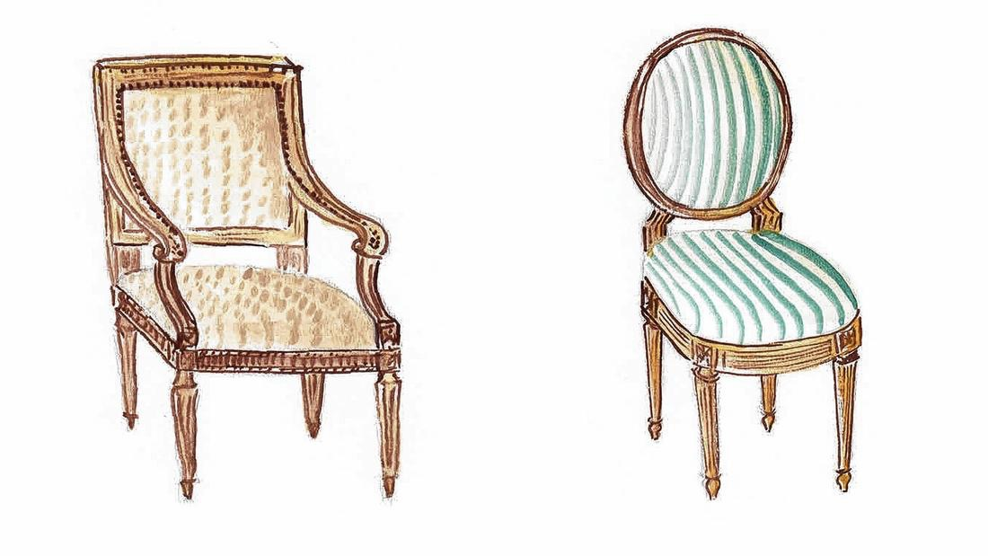

Studio Contact: Jason Jobson – Christophe Pourny Studio
Jason@ChristophePourny.com
Publishing Contact: Patrick Leonard – Workman Publishing
Patrickl@artisanbooks.com
